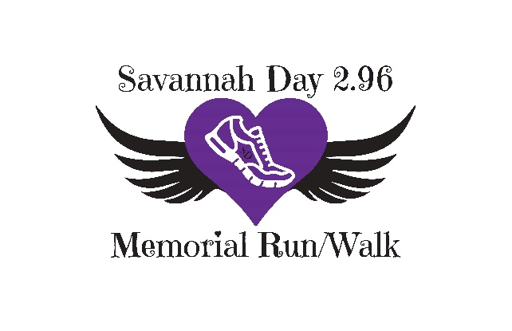
Savannah Day 2.96 Memorial Run/ Walk
Friday, July 29th 2022 at 7pm.

Pre registration or same day registration starts at 5:30pm in Sidney, IL (20 mins outside Champaign, IL) $25 Race + T’shirt: (only pre registered runners are guaranteed a race shirt ).

All Proceeds go to support the Savannah Day Girls Athetic Scholarship.
**We will have extra Race Shirts on race day for purchase**
Registration Form: Pre-registration forms and payment are due by Saturday July 16th. Please mail the registration form and payment to Attn: Savannah Day 2.96 Memorial Run/Walk to PO Box 268, Sidney IL 61877. We will have same day registration at no additional cost.
Name: _____________________________________________________________________________________________________________
Phone Number:_______________________________________________Email:________________________________________________________
Emergency Contact: Name: ______________________________ Phone: _______________________________________________________
Date of Birth: ______________________________ T’shirt Size: ___________ Fee enclosed: Cash or Check: #______________
If you are not over 18, please have a parent or guardian sign below giving you permission to participate in the Savannah Day 2.96 Memorial Run/ Walk.
I know that running [volunteering for] a road race is potentially hazardous activity, which could cause injury or death. I will not enter and participate unless I am medically able and properly trained, and by my signature, I certify that I am medically able to perform this event, and am in good health, and I am properly trained. I agree to abide by any decision of a race official relative to any aspect of my participation in this event, including the right of any official to deny or suspend my participation for any reason whatsoever. I attest that I have read the rules of the race and agree to abide by them. I assume all risks associated with running in this event, including but no limited to: falls, contact with other participants, the effects of the weather, including high heat and/or humidity, traffic and the conditions of the road [insert any specific risks related to your here, e.g. “the alligators who bask in the sun at the corner of 4th and Sunset St…”’], all such risks being known and appreciated by me. I understand that bicycles, skateboards, baby joggers, roller skates or roller blades, animals, and personal music players are not allowed in the race and I will abide by all race rules. Having read this waiver and knowing these facts and inconsideration of your accepting my entry, I, for myself and anyone entitled to act on my behalf, waive and release the Savannah Day 2.96 Memorial Run/ Walk and Savannah Day Memorial, the town of Sidney, Illinois, and the Road Runners Club of America, all event sponsors, their representatives and successors from all claims or liabilities of any kind arising out of my participation in this event, even though that liability may arise out of negligence or carelessness on the part of the persons named in this waiver.
Signature: ___________________________________ Parent’s Signature if under 18 years: __________________________
Date: _________________ Date: _________________
I grant permission to all of the foregoing to use my photographs, motion pictures, recordings, or any other record of this event for any legitimate purpose. I understand that this event does not provide for refunds in the event of a cancellation, and by signing this waiver, I consent that I am not entitled to a refund if the event is cancelled before or during the event.
Signature: ___________________________________ Parent’s Signature if under 18 years: __________________________
Check our Facebook for more info. @Savannahday2.96 Memorial Run/ walk

