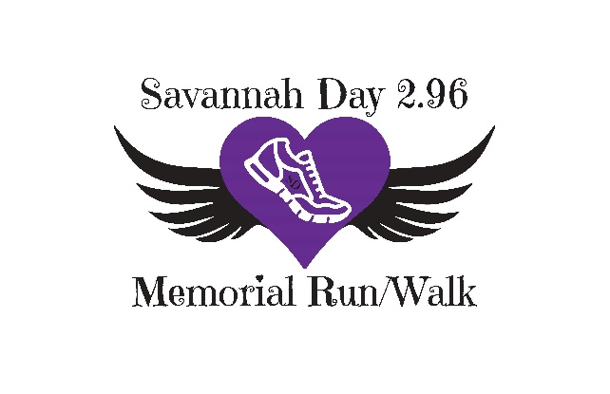
Savannah Day 2.96 Memorial Walk/ Run T-shirt Order Form Only.
Run Is Friday July 29th 2022 @ 7pm, Sidney, IL.
- Pick up can be on Race day
- If you choose to have your shirt mailed It will be an additional $2 per shirt
All Proceeds go to support the Savannah Day Girls Athletic Scholarship
YS- YL are $12 Adult S- XL $15. 2XL and up $20
T- Shirt Order Form: Forms and payment are due by Saturday July 16th. Please mail the T-shirt form and payment to Attn: Savannah Day 2.96 Memorial Run/ Walk PO BOX 268, Sidney, IL 61877. We take cash and checks or Venmo. Please make checks payable to Savannah Day Memorial Fund.
Name: ________________________________________________________________________________
YS:_______ YM:_______ YL:_______
Small:_________ Medium:_________ Large:__________ XLarge:___________
2XL:__________ 3XL:_________
Pick up: _____
Mailed: _____ $2 fee per shirt
Address for shipping :__________________________________________________________________

Phone Number:_________________________________________________________________________
Email: ________________________________________________________________________________
Payment Enclosed: Cash or Check # _______________ Date:________________

Check us out on Facebook or on our website http://www.savannahday296memorialrunwalk.com for more information and race updates!

